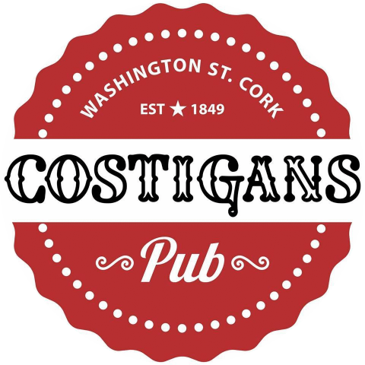
0214273350
Finger Food Selections
Option 1 €25 per platter (feeds 4 people)
Home-made breaded chicken tenders -Dijon and sesame Cocktail Sausages - Tossed chicken wings – lightly fried Calamari
Selection of dips
~~~~~~~~
Option 2 €30 per platter (feeds 4 people)
Pulled pork mini sliders- Home-made breaded chicken tenders – Lightly Toasted Brie and Pesto Bruschetta – Hand cut Pork pin wheels .
Selection of dips
~~~~~~~~~~~

Dips
- Smoked paprika and roast garlic aioli
- Sweet chilli sauce
- Extra option of chips @ €3.00 per portion

11 Washington St. 021-427-3350
www.costiganspub.ie / email costiganspubcork@gmail.com

